

***Personal Care Easy Read Version***



***What is the Provision of Personal Intimate Care?***

The provision of Personal Intimate Care is a very broad term used to refer to help in supporting you with personal hygiene and toileting, along with dressing and maintaining your personal appearance.

Extern does not provide an individual personal care service, however sometimes a service user will need support with their intimate or individual care needs following an unforeseen incident/accident.

Consent must be sought by you the service user and/or parent/guardian before any individual care needs is addressed. Verbal consent will be sought before each educational activity takes place.

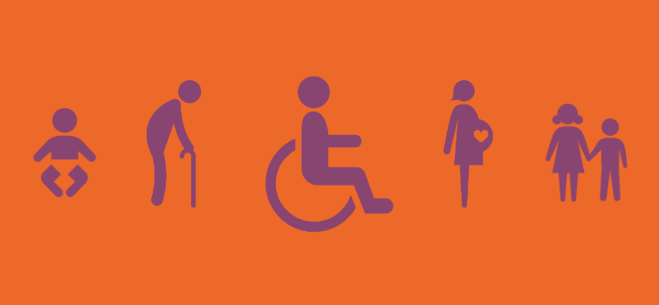

**Intimate care**: Is defined as care tasks in supporting your bodily functions, body products, and personal hygiene which require direct or indirect contact with your intimate area. i.e sometimes there can be toileting accidents that you may need help with or showering etc.

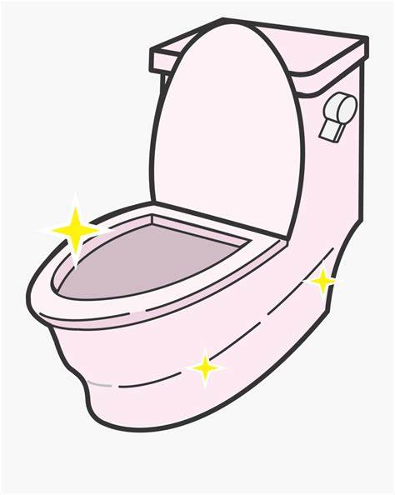 

**Individual care**: Is when we can support you educationally in developing everyday life skills. This can be when your keyworker can demonstrate things like shaving, oral care, hair/skin care, cooking/food preparation/ eating etc.

  

Shaving Brushing Teeth Hair Brushing

 

Food Prep Cooking

Any service user of Extern that may require individual care will be treated with respect and dignity. You will be listened to and your views will be taken into account. It is your right to feel safe and secure at all times, and you have the right to personal privacy.

When possible your key worker will encourage you verbally at a safe distance. Sometimes you will need more direct help. Your keyworker will always explain what they are going to do and how they are going to do it. PPE gear will be worn by staff where necessary. 