

***Keeping Adults Safe from Abuse and Neglect Easy Read Version***

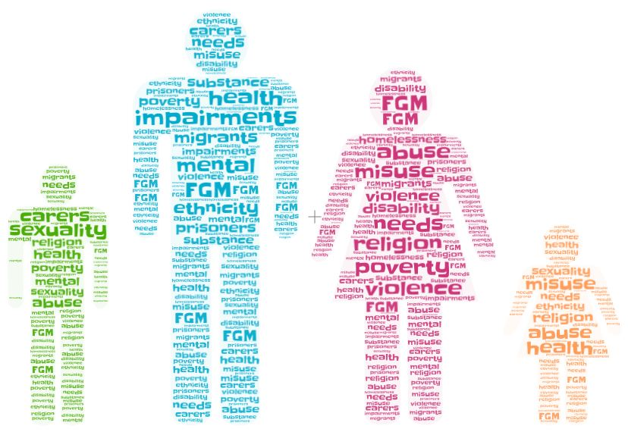

**Safeguarding:** Means keeping people safe from abuse and neglect, and they can be independent to make choices and decisions about how they want to live.

**Neglect:** This is when your support and care needs are not been met by those who support you.

**Abuse:** Is when someone says or does something to cause you harm or frighten you.

It is the LAW for us to protect and safeguard those we support from neglect and abuse.

Extern staff will ensure that you are supported to understand all information that important to you in a form that is accessible to your needs.

**Adults who may be at risk of Neglect or Abuse**

* People with a physical disability
* People with a learning disability
* People with a mental health problem
* People with a long term illness or condition
* People with a visual or hearing impairment
* Older People

**People who could Neglect or Abuse you**

* Someone in your family
* Neighbours
* Professionals
* Friends
* Volunteers
* Carers
* Staff
* A Stranger

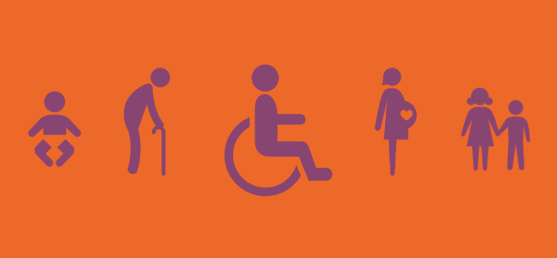

**The Types of Abuse are:**

**Physical Abuse:** Could be someone hitting, slapping, pushing, or kicking you.

**Psychological Abuse:** Could be someone unkind to you, threatening you, swearing at you, calling you names or even ignoring you.

**Modern Slavery:** Could be being forced to work by people who are cruel to you or abuse you.

**Domestic Abuse:** Could be physical, emotional, sexual, or financial abuse. Domestic abuse is when the person abusing you is a member of your family or domestic abuse.

**Financial or Material Abuse:** Could be someone taking your money or other things that belong to you.

**Sexual Abuse:** Could be someone touching your body or private parts without your permission. Or someone making you touch them in a way you do not want.

**Discriminatory Abuse**: Could be someone bullying you or hurting you because of: your religion, a disability, your age, your sexual partner, the colour of your skin or hair, where you come from, the language you speak.

**Organisational Abuse:** Could be that those who support you or other professionals treat you badly, neglect you, or provide a bad service.

**Neglect:** Could be that you are not being given enough food, not been given your medication, or not been kept warm.

**Self-Neglect:** Is when someone does not take care of themselves properly.

**Where can abuse happen?**

Abuse can happen anywhere, at home, hospital, at a day service, a respite service, at work, in the community (even walking the street), at a social club.



**What to do if you feel you or another adult is at risk of neglect or abuse**

Contact the **HSE Live**: 1800 700 700

Monday to Friday 8am-8pm

Saturday and Sunday 9am-5pm

**Gardaí: 999 or 112**

**Member of management at EOSS**

Bryan Gough: 0860082042

Meagan Cosgrave: 0860749393

Charlotte Hackett: 0860749394

**What happens when you make contact?**

* They will listen to you and tell you what will happen next
* They will tell Extern’s safeguarding team about your safeguarding concern
* Their aim is to keep the person safe while helping and supporting them
* They may follow up with a safeguarding enquiry to the HSE.

**What will happen if there is a safeguarding enquiry?**

* The adult at risk will be asked what they want to happen and services will plan safeguarding around this.
* Sometimes service will have to make decisions in the best interest of the person at risk.
* The adult at risk will get clear and simple information about what abuse is and who to ask for help.
* The adult at risk will get help and support to tell people about the abuse.
* Staff will look after their personal information and only share it when this helps to keep the adult at risk safe.
* The adult at risk will know what all the different people should do to keep them safe.

**Other supports for adults at risk of neglect or abuse**

* They may arrange for an advocate if:
* The adult at risk needs support with the safeguarding concern and they do not have anyone who can support them.
* The adult at risk is not able to understand or recognise that they are at risk or abuse or neglect and they have no one to represent their views.
* An ADVOCATE is someone who supports a person to understand information and to express their needs and wishes