

***Restrictive Practice Easy Read Version***



**At Extern sometimes we need to use restrictive practice as a last resort only to keep you safe! Your keyworkers and others who support you at Extern are specially trained in restraint management and de-escalation strategies called MAPA.**

**What is Restrictive Practice?**

Restrictive practices are things that limit the rights of a person, like being able to move around freely. Restrictive Practice is used to stop a person from doing behaviours of concern.

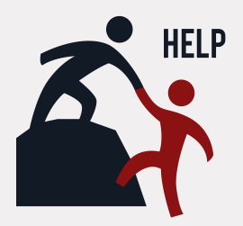• A behaviour of concern might be a behaviour like when you hurt yourself or hurt another person, or it might be behaviour like when you are angry and break furniture, or when you run away from people who help you.

There are a lot of laws that talk about different parts of Restrictive Practice.

• There is a special law called the **Humans Right Act 2004**.

• The ACT now has a new law called the **Senior Practitioner Act 2018** The Senior Practitioner is in charge of the rules for Restrictive Practice.

• The Senior Practitioner is **Tracey Harkness.**

* **All** Restrictive Practices affect your Human Rights. The new Senior Practitioner Act talks about Restrictive Practices.

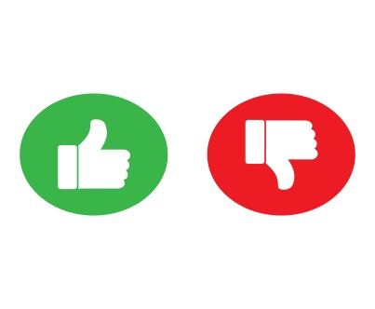

* The law says that Restrictive Practices can only be used if there is a risk to safety right at that time.
* The type of Restricted Practice used must be the least restrictive way.
* Restricted Practice can only be used in special situations
* Restricted Practice is the very last option!
* Restricted Practice has to be used the shortest time possible and with the right help restrictive practices should not need to be used.

**What are different types of restrictive practices?**

* **Chemical restraint:** this is when you are given a medication to change your behaviour? if the medication is given to you to treat a physical or mental illness you have, this is not chemical restraint
* **Physical restraint:** is when another person holds you strong so you cannot move. It is not the same as when someone holds your hand to cross the road.
* **Mechanical restraint:** is when equipment is used on you that does not let you move.

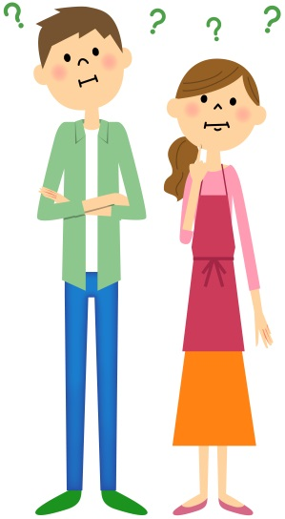

|  |  |
| --- | --- |
| **If you are worried about restrictive practice, Talk to your keyworker or another staff member** |  |
| **OR**  **Call** 086 0082042 Bryan Gough  048 90840555 Head Office | Image result for phone |
| **Email** [bryan.gough@extern.org](mailto:bryan.gough@extern.org) | **Image result for email** |
|  |  |
|  |  |